
The Sunday of the Passion: Palm Sunday
Holy Eucharist: Rite II

With God’s help, we the people of Saint Andrew’s Church seek to know and accept God’s love in Jesus Christ for all people and to witness to God’s love in word and action.

April 5, 2020 10:00 a.m.
Prelude Palm Sunday Prelude Lisa Shoemaker-Lomeyer (b.1956)
The Liturgy of the Palms
Priest: Blessed is the King who comes in the name of the Lord.
People: Peace in heaven and glory in the highest.
Priest: Let us pray. Assist us mercifully with your help, O Lord God of our salvation, that we may enter with joy upon the contemplation of those mighty acts, whereby you have given us life and immortality; through Jesus Christ our Lord.
People: Amen.

The Palms Gospel: Matthew 21:1-11
Deacon: The Holy Gospel of our Lord Jesus Christ according to Matthew.
People: Glory to you, Lord Christ.
After telling a parable to the crowd at Jericho, Jesus went on ahead, going up to Jerusalem. When he had come near Bethphage and Bethany, at the place called the Mount of Olives, he sent two of the disciples, saying, "Go into the village ahead of you, and as you enter it you will find tied there a colt that has never been ridden. Untie it and bring it here. If anyone asks you, 'Why are you untying it?' just say this, 'The Lord needs it.'" So those who were sent departed and found it as he had told them. As they were untying the colt, its owners asked them, "Why are you untying the colt?" They said, "The Lord needs it." Then they brought it to Jesus; and after throwing their cloaks on the colt, they set Jesus on it. As he rode along, people kept spreading their cloaks on the road. As he was now approaching the path down from the Mount of Olives, the whole multitude of the disciples began to praise God joyfully with a loud voice for all the deeds of power that they had seen, saying, "Blessed is the king who comes in the name of the Lord! Peace in heaven, and glory in the highest heaven!" Some of the Pharisees in the crowd said to him, "Teacher, order your disciples to stop." He answered, "I tell you, if these were silent, the stones would shout out."

Deacon: The Gospel of the Lord.
People: Praise to you, Lord Christ.
Please hold Palms up high as they are blessed.
Priest: The Lord be with you.
People: And also with you.
Priest: Let us give thanks to the Lord our God.
People: It is right to give him thanks and praise.
Priest: It is right to praise you, Almighty God, for the acts of love by which you have redeemed us through your Son Jesus Christ our Lord. On this day he entered the holy city of Jerusalem in triumph and was proclaimed as King of kings by those who spread their garments and branches of palm along his way. Let these branches be for us signs of his victory, and grant that we who bear them in his name may ever hail him as our King, and follow him in the way that leads to eternal life; who lives and reigns in glory with you and the Holy Spirit, now and for ever. Amen.
Priest: Blessed is he who comes in the name of the Lord.
People: Hosanna in the highest.
Deacon: Let us go forth in peace.
People: In the name of Christ, Amen.
Processional Hymn 154: “All Glory, Laud, and Honor” Valet will ich dir geben
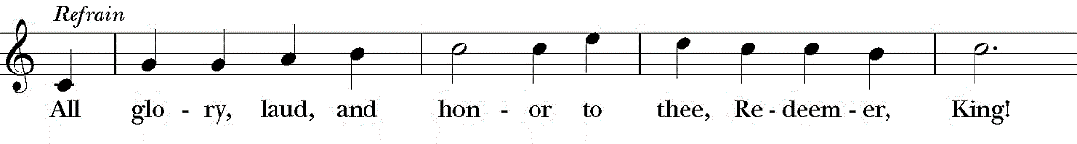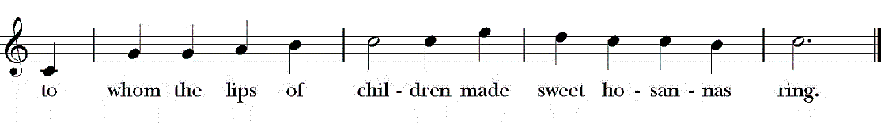
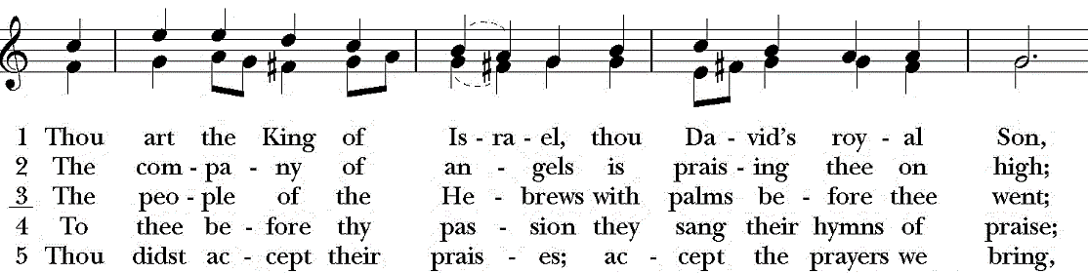
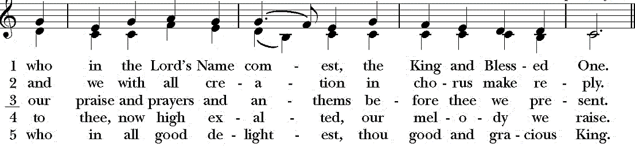
The Liturgy of the Word of God
Priest: The Lord be with you.
People: And also with you.
Priest: Let us pray.
The Collect of the Day: Almighty and everliving God, in your tender love for the human race you sent your Son our Savior Jesus Christ to take upon him our nature, and to suffer death upon the cross, giving us the example of his great humility: Mercifully grant that we may walk in the way of his suffering, and also share in his resurrection; through Jesus Christ our Lord, who lives and reigns with you and the Holy Spirit, one God, for ever and ever. Amen.

The First Reading: Isaiah 50:4-9

The Lord GOD has given me the tongue of a teacher, that I may know how to sustain the weary with a word. Morning by morning he wakens-- wakens my ear to listen as those who are taught. The Lord GOD has opened my ear, and I was not rebellious, I did not turn backward. I gave my back to those who struck me, and my cheeks to those who pulled out the beard; I did not hide my face from insult and spitting. The Lord GOD helps me; therefore I have not been disgraced; therefore I have set my face like flint, and I know that I shall not be put to shame; he who vindicates me is near. Who will contend with me? Let us stand up together. Who are my adversaries? Let them confront me. It is the Lord GOD who helps me; who will declare me guilty?

Reader: The Word of the Lord.
People: Thanks be to God.

Psalm 31:9-16 In te, Domine, speravi BCP 622

9 Have mercy on me, O Lord, for I am in trouble; *
my eye is consumed with sorrow,
and also my throat and my belly.
10 For my life is wasted with grief,
and my years with sighing; *
my strength fails me because of affliction,
and my bones are consumed.
11 I have become a reproach to all my enemies and even to my neighbors,
a dismay to those of my acquaintance; *
when they see me in the street they avoid me.
12 I am forgotten like a dead man, out of mind; *
I am as useless as a broken pot.
13 For I have heard the whispering of the crowd;
fear is all around; *
they put their heads together against me;
they plot to take my life.
14 But as for me, I have trusted in you, O Lord. *
I have said, "You are my God.
15 My times are in your hand; *
rescue me from the hand of my enemies,
and from those who persecute me.
16 Make your face to shine upon your servant, *
and in your loving-kindness save me."

The Second Reading: Philippians 2:5-11
Let the same mind be in you that was in Christ Jesus, who, though he was in the form of God, did not regard equality with God as something to be exploited, but emptied himself, taking the form of a slave, being born in human likeness. And being found in human form, he humbled himself and became obedient to the point of death-- even death on a cross. Therefore God also highly exalted him and gave him the name that is above every name, so that at the name of Jesus every knee should bend, in heaven and on earth and under the earth, and every tongue should confess that Jesus Christ is Lord, to the glory of God the Father.
Reader: The Word of the Lord.
People: Thanks be to God.
Hymn 170 “To Mock Your Reign, O Dearest Lord” The Third Tune
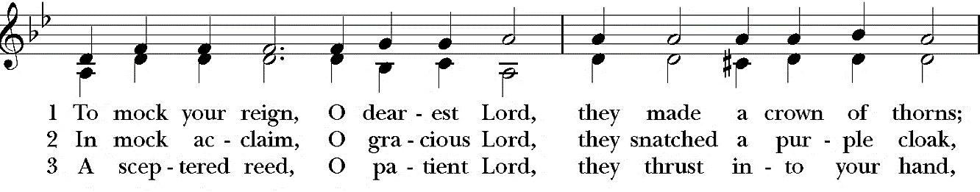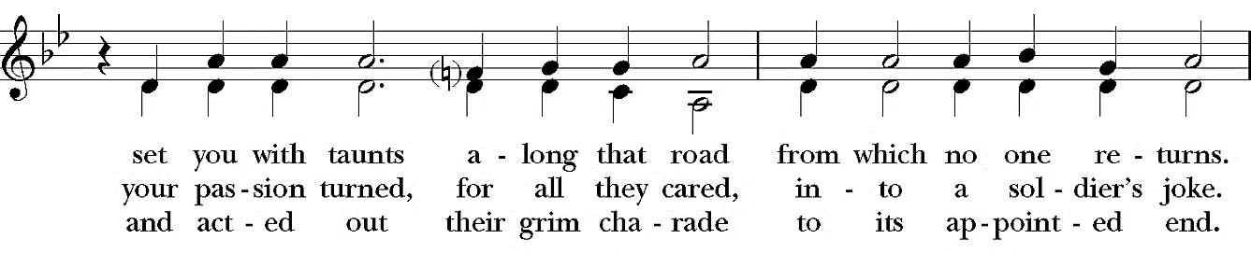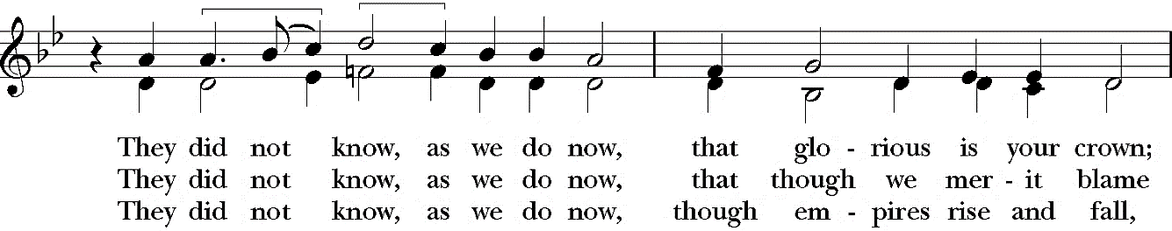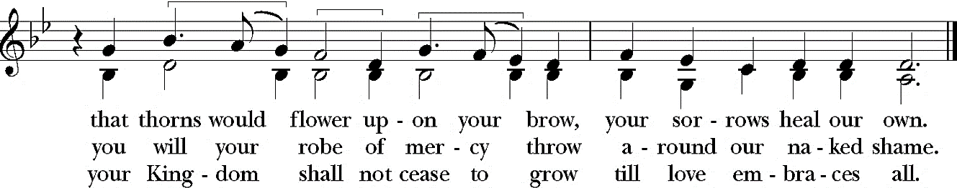

The Passion According to Matthew (26:14 – 27:66)
The customary responses before and after the Gospel are omitted.
The congregation remaining seated, the Passion Gospel is read in parts, led by a narrator who begins by saying:
The Passion of our Lord Jesus Christ according to Saint Matthew
NARRATOR: One of the twelve, who was called Judas Iscariot, went to the chief priests and said,
JUDAS: What will you give me if I betray Jesus to you?
NARRATOR: The priests paid him thirty pieces of silver. And from that moment Judas began to look for an opportunity to betray Jesus. On the first day of Unleavened Bread the disciples came to Jesus, saying,
PETER: Where do you want us to make the preparations for you to eat the Passover?
NARRATOR: Jesus said,
JESUS: Go into the city to a certain man, and say to him, "The Teacher says, My time is near; I will keep the Passover at your house with my disciples." NARRATOR: So the disciples did as Jesus had directed them, and they prepared the Passover meal. When it was evening, Jesus took his place with the twelve; and while they were eating, he said,
JESUS: Truly I tell you, one of you will betray me.
NARRATOR: And the disciples became greatly distressed and began to say to him one after another,
PETER: Surely not I, Lord?
NARRATOR: He answered,
JESUS: The one who has dipped his hand into the bowl with me will betray me. The Son of Man goes as it is written of him, but woe to that one by whom the Son of Man is betrayed! It would have been better for that one not to have been born.
NARRATOR: Judas, who betrayed him, said,
JUDAS: Surely not I, Rabbi?
NARRATOR: Jesus replied,
JESUS: You have said so.
NARRATOR: While they were eating, Jesus took a loaf of bread, and after blessing it he broke it, gave it to the disciples, and said,
JESUS: Take, eat; this is my body.
NARRATOR: Then he took a cup, and after giving thanks he gave it to them, saying,
JESUS: Drink from it, all of you; for this is my blood of the covenant, which is poured out for many for the forgiveness of sins. I tell you, I will never again drink of this fruit of the vine until that day when I drink it new with you in my Father's kingdom.
NARRATOR: When they had sung the hymn, they went out to the Mount of Olives. Then·Jesus said to his disciples,
JESUS: You will all become deserters because of me this night; for it is written, "I will strike the shepherd, and the sheep of the flock will be scattered," But after I am raised up, I will go ahead of you to Galilee.
NARRATOR: Peter said to him,
PETER: Though all become deserters because of you, I will never desert you.
NARRATOR: Jesus said to him,
JESUS: Truly I tell you, this very night, before the cock crows, you will deny me three times.
NARRATOR: Peter said to him,
PETER: Even though I must die with you, I will not deny you.
NARRATOR: And so said all the disciples. Then Jesus went with his disciples to a place called Gethsemane; and he said to them,
JESUS: Sit here while I go over there and pray.
NARRATOR: He took with him Peter and the two sons of Zebedee and began to be grieved and agitated. Then he said to them,

JESUS: I am deeply grieved, even to death; remain here, and stay awake with me.

NARRATOR: And going a little farther, Jesus threw himself on the ground and prayed,

JESUS: My Father, if it is possible, let this cup pass from me; yet not what I want but what you want.

NARRATOR: Then he came to the disciples and found them sleeping; and he said to Peter,

JESUS: So, could you not stay awake with me one hour? Stay awake and pray that you may not come into the time of trial; the spirit indeed is willing, but the flesh is weak.

NARRATOR: Again Jesus went away for the second time and prayed,

JESUS: My Father, if this cannot pass unless I drink it, your will be done.

NARRATOR: Again Jesus came and found the disciples sleeping, for their eyes were heavy. So leaving them again, he went away and prayed for the third time, saying the same words. Then he came to the disciples and said to them,

JESUS: Are you still sleeping and taking your rest? See, the hour is at hand, and the Son of Man is betrayed into the hands of sinners. Get up, let us be going. See, my betrayer is at hand.

NARRATOR: While Jesus was still speaking, Judas, one of the twelve, arrived; with him was a large crowd with swords and clubs, from the chief priests and the elders of the people. Now the betrayer had given the crowd a sign, saying, JUDAS: The one I will kiss is the man; arrest him.

NARRATOR: At once Judas came up to Jesus and said,

JUDAS: Greetings, Rabbi!

NARRATOR: and kissed him. Jesus said to him,

JESUS: Friend, do what you are here to do.

NARRATOR: Then the crowd came and laid hands on Jesus and arrested him. Suddenly, one of those with Jesus put his hand on his sword, drew it, and struck the slave of the high priest, cutting off his ear. Then Jesus said to him,

JESUS: Put your sword back into its place; for all who take the sword will perish by the sword. Do you think that I cannot appeal to my Father, and he will at once send me more than twelve legions of angels? But how then would the scriptures be fulfilled, which say it must happen in this way?

NARRATOR: At that hour Jesus said to the crowds,

JESUS: Have you come out with swords and clubs to arrest me as though I were a bandit? Day after day I sat in the temple teaching, and you did not arrest me. But all this has taken place, so that the scriptures of the prophets may be fulfilled. NARRATOR: Then all the disciples deserted Jesus and fled. Those who had arrested Jesus took him to Caiaphas the high priest, in whose house the scribes and the elders had gathered. But Peter was following him at a distance, as far as the courtyard of the high priest; and going inside, Peter sat with the guards in order to see how this would end. Now the chief priests and the whole council were looking for false testimony against Jesus so that they might put him to death, but they found none, though many false witnesses came forward. At last two came forward and said,

FALSE WITNESS: This fellow said, "I am able to destroy the temple of God and to build it in three days."

NARRATOR: The high priest stood up and said to Jesus,

HIGH PRIEST: Have you no answer? What is it that they testify against you?

NARRATOR: But Jesus was silent. Then the high priest said to Jesus,

HIGH PRIEST: I put you under oath before the living God, tell us if you are the Messiah, the Son of God.

NARRATOR: Jesus said to him,

JESUS: You have said so. But I tell you, from now on you will see the Son of Man seated at the right hand of Power and coming on the clouds of heaven.

NARRATOR: Then the high priest tore his clothes and said,

HIGH PRIEST: He has blasphemed! Why do we still need witnesses? You have now heard his blasphemy. What is your verdict?

NARRATOR: The scribes and elders answered,

SCRIBE: He deserves death.

NARRATOR: Then they spat in Jesus' face and struck him; and some slapped him, saying,

ELDER: Prophesy to us, you Messiah! Who is it that struck you?

NARRATOR: Now Peter was sitting outside in the courtyard. A servant-girl came to him and said,

SERVANT 1: You also were with Jesus the Galilean.

NARRATOR: But Peter denied it before all of them, saying,

PETER: I do not know what you are talking about.
NARRATOR: When Peter went out to the porch, another servant-girl saw him, and she said to the bystanders,
SERVANT 2: This man was with Jesus of Nazareth.
NARRATOR: Again Peter denied it with an oath, PETER: I do not know the man.
NARRATOR: After a little while the bystanders came up and said to Peter,
BYSTANDER 1: Certainly you are also one of them, for your accent betrays you.
NARRATOR: Then Peter began to curse, and he swore an oath,
PETER: I do not know the man!
NARRATOR: At that moment the cock crowed. Then Peter remembered what Jesus had said:
JESUS: Before the cock crows, you will deny me three times.
NARRATOR: And Peter went out and wept bitterly. When morning came, all the chief priests and the elders of the people conferred together against Jesus in order to bring about his death. They bound him, led him away, and handed him over to Pilate the governor. When Judas, his betrayer, saw that Jesus was condemned, he repented and brought back the thirty pieces of silver to the chief priests and the elders. Judas said,
JUDAS: I have sinned by betraying innocent blood.
NARRATOR: But the chief priests and elders said,
CHIEF PRIEST: What is that to us? See to it yourself.
NARRATOR: Throwing down the pieces of silver in the temple, Judas departed; and he went and hanged himself. But the chief priests, taking the pieces of silver, said,
CHIEF PRIEST: It is not lawful to put them into the treasury, since they are blood money.
NARRATOR: After conferring together, they used them to buy the potter's field as a place to bury foreigners. For this reason that field has been called the Field of Blood to this day. Then was fulfilled what had been spoken through the prophet Jeremiah,
PROPHET: And they took the thirty pieces of silver, the price of the one on whom a price had been set, on whom some of the people of lsrael had set a price, and they gave them for the potter's field, as the Lord commanded me.
NARRATOR: Now Jesus stood before the governor; and the governor asked him,
PILATE: Are you the King of the Jews?
NARRATOR: Jesus said,
JESUS: You say so.
NARRATOR: But when Jesus was accused by the chief priests and elders, he did not answer. Then Pilate said to him,
PILATE: Do you not hear how many accusations they make against you? NARRATOR: But Jesus gave him no answer, not even to a single charge, so that the governor was greatly amazed. Now at the festival the governor was accustomed to release a prisoner for the crowd, anyone whom they wanted. At that time they had a notorious prisoner, called Jesus Barabbas. So after they had gathered, Pilate said to the crowd,
PILATE: Whom do you want me to release for you, Jesus Barabbas or Jesus who is called the Messiah?
NARRATOR: For Pilate realized that it was out of jealousy that the chief priests and the elders had handed Jesus over. While Pilate was sitting on the judgment seat, his wife sent word to him,
WIFE: Have nothing to do with that innocent man, for today I have suffered a great deal because of a dream about him.
NARRATOR: Now the chief priests and the elders persuaded the crowds to ask for Barabbas and to have Jesus killed. The governor again said to them,
PILATE: Which of the two do you want me to release for you?
NARRATOR: And the crowd said,
CROWD: Barabbas.
NARRATOR: Pilate said to them,
PILATE: Then what should I do with Jesus who is called the Messiah? NARRATOR: All of them said,
CROWD: Let him be crucified!
NARRATOR: Then Pilate asked,
PILATE: Why, what evil has he done?
NARRATOR: But the crowd shouted all the more,
CROWD: Let him be crucified!
NARRATOR: So when Pilate saw that he could do nothing, but rather that a riot was beginning, he took some water and washed his hands before the crowd, saying,
PILATE: I am innocent of this man's blood; see to it yourselves.
NARRATOR: Then the people as a whole answered,
CROWD: His blood be on us and on our children!
NARRATOR: So Pilate released Barabbas for them; and after flogging Jesus, he handed him over to be crucified. Then the soldiers of the governor took Jesus into the governor's headquarters, and they gathered the whole cohort around him. They stripped Jesus and put a scarlet robe on him, and after twisting some thorns into a crown, they put it on his head. They put a reed in his right hand and knelt before him and mocked him, saying,
SOLDIER: Hail, King of the Jews!
NARRATOR: They spat on Jesus and took the reed and struck him on the head. After mocking him, they stripped him of the robe and put his own clothes on him. Then they led him away to crucify him. As they went out, the soldiers came upon a man from Cyrene named Simon; they compelled this man to carry Jesus' cross.
(All stand.)
And when the soldiers came to a place called Golgotha (which means Place of a Skull), they offered Jesus wine to drink, mixed with gall; but when he tasted it, he would not drink it. And when the soldiers had crucified Jesus, they divided his clothes among themselves by casting lots; then they sat down there and kept watch over him. Over Jesus' head they put the charge against him, which read,
SOLDIER: This is Jesus, the King of the Jews.
NARRATOR: Then two bandits were crucified with Jesus, one on his right and one on his left. Those who passed by derided hirn, shaking their heads and saying,
PASSERBY 1: You who would destroy the temple and build it in three days, save yourself!
PASSERBY 2: If you are the Son of God, come down from the cross.
NARRATOR: In the same way the chief priests also, along with the scribes and elders, were mocking Jesus, saying,
CHIEF PRIEST: He saved others; he cannot save himself.
SCRIBE: He is the King of Israel; let him come down from the cross now, and we will believe in him.
ELDER: He trusts in God; let God deliver him now, if God wants to; for this man said, "I am God's Son."
NARRATOR: The bandits who were crucified with Jesus also taunted him in the same way. From noon on, darkness came over the whole land until three in the afternoon. And about three, o'clock Jesus cried with a loud voice,
JESUS: Eli, Eli, lema sabachthani?
NARRATOR: that is,
JESUS: My God, my God, why have you forsaken me?
NARRATOR: When some of the bystanders heard it, they said,
BYSTANDER 1: This man is calling for Elijah.
NARRATOR: At once one of them ran and got a sponge, filled it with sour wine, put it on a stick, and gave it to him to drink. But the others said,
BYSTANDER 2: Wait, let us see whether Elijah will come to save him.
NARRATOR: Then Jesus cried again with a loud voice and breathed his last. (Silence may be kept.) At that moment the curtain of the temple was torn in two, from top to bottom. The earth shook, and the rocks were split. The tombs also were opened, and many bodies of the saints who had fallen asleep were raised. After his resurrection they came out of the tombs and entered the holy city and appeared to many. Now when the centurion and those with him, who were keeping watch over Jesus, saw the earthquake and what took place, they were terrified and said,
CENTURION: Truly this man was God's Son!
The Sermon The Rev. Jeffrey A. Packard
The Prayers of the People, Form II BCP 385
In the course of the silence after each bidding, the People offer their own prayers, either silently or in the comments on your screen.
I ask your prayers for God's people throughout the world; for our Presiding Bishop, Michael; our Bishop, Audrey; our priest, Jeffrey; our deacon, Joe; and for all ministers and people.
Pray for the Church. Silence
I ask your prayers for peace; for goodwill among nations; and for the well-being of all people.
Pray for justice and peace. Silence
I ask your prayers for the poor, the sick, the hungry, the oppressed, and those in prison.
Pray for those in any need or trouble. Silence
I ask your prayers for all who seek God, or a deeper knowledge of him.
In the Diocesan cycle of prayer, we pray for All Saints, Williamsport, and Christ Church, Milton.
In the Anglican cycle of prayer, we pray for the Province of the Indian Ocean.
Pray that they may find and be found by him. Silence
I ask your prayers for the departed.
Pray for those who have died. Silence
I ask your prayers for all those on our prayer list.
Pray for all who suffer in body, mind, or spirit. Silence
Members of the congregation may ask the prayers or the thanksgivings of those present in the comments.
Praise God for those in every generation in whom Christ has been honored.
Pray that we may have grace to glorify Christ in our own day. Silence
The Priest will add a concluding collect.
The Peace BCP 360
The peace of the Lord be always with you.
People And also with you.

The Holy Communion
The Offertory Anthem Hymn 439 “What Wondrous Love Is This” Wondrous Love
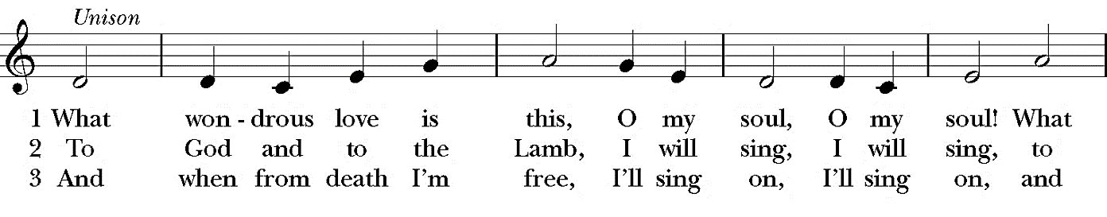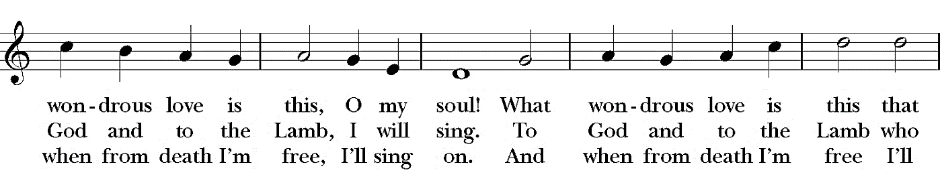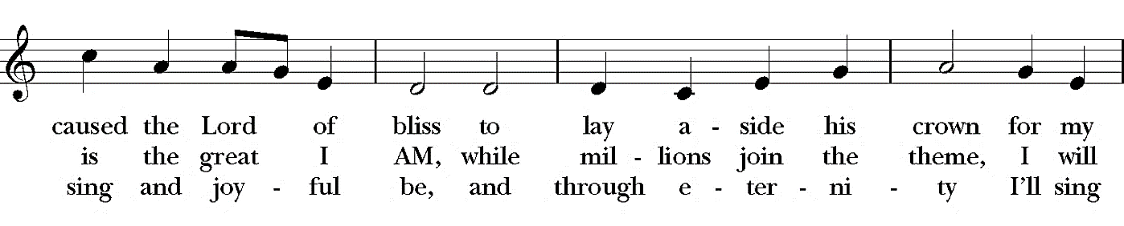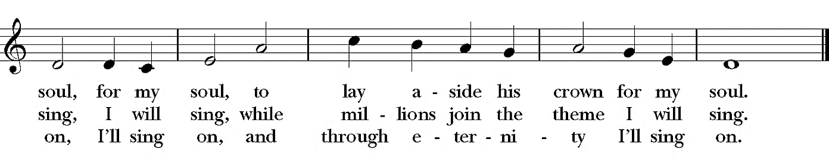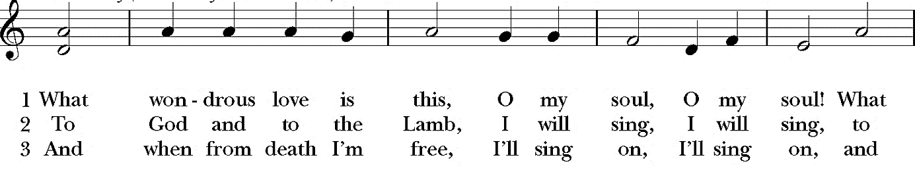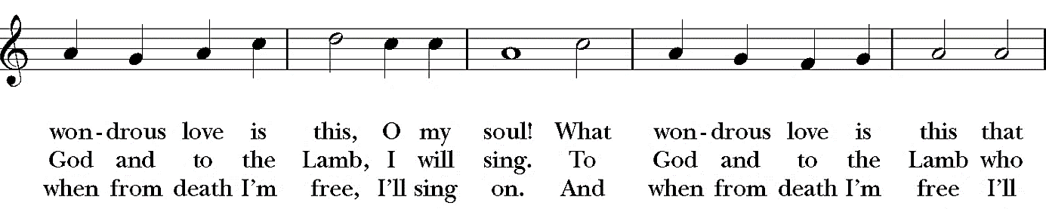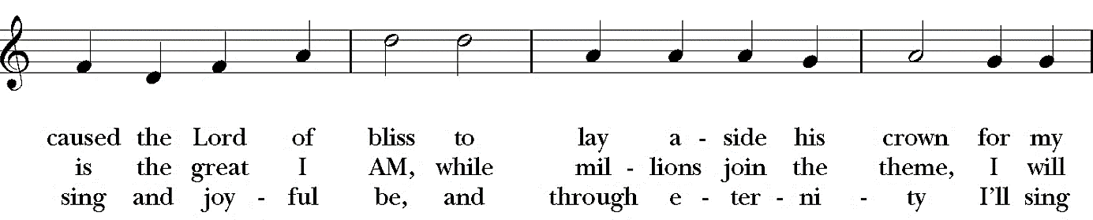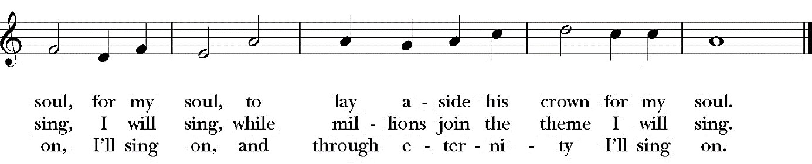
The Great Thanksgiving Eucharistic Prayer A BCP 361
Eucharistic Prayer A
Priest: The Lord be with you.
People: And also with you.
Priest: Lift up your hearts.
People: We lift them to the Lord.
Priest: Let us give thanks to the Lord our God.
People: It is right to give him thanks and praise.
It is right, and a good and joyful thing, always and everywhere to give thanks to you, Father Almighty, Creator of heaven and earth. Through Jesus Christ our Lord. For our sins he was lifted high upon the cross, that he might draw the whole world to himself; and, by his suffering and death, he became the source of eternal salvation for all who put their trust in him. Therefore we praise you, joining our voices with Angels and Archangels and with all the company of heaven, who forever sing this hymn to proclaim the glory of your Name:
Sanctus
Holy, holy, holy Lord,
God of power and might,
Heaven and earth are full of Your glory.
Hosanna in the highest.
Blessed is He who comes in the name of the Lord.
Hosanna in the highest.
Then the Priest continues.
Holy and gracious Father: In your infinite love you made us for yourself, and, when we had fallen into sin and become subject to evil and death, you, in your mercy, sent Jesus Christ, your only and eternal Son, to share our human nature, to live and die as one of us, to reconcile us to you, the God and Father of all. He stretched out his arms upon the cross, and offered himself, in obedience to your will, a perfect sacrifice for the whole world.
On the night he was handed over to suffering and death, our Lord Jesus Christ took bread; and when he had given thanks to you, he broke it, and gave it to his disciples, and said, "Take, eat: This is my Body, which is given for you. Do this for the remembrance of me."
After supper he took the cup of wine; and when he had given thanks, he gave it to them, and said, "Drink this, all of you: This is my Blood of the new Covenant, which is shed for you and for many for the forgiveness of sins. Whenever you drink it, do this for the remembrance of me.
"Therefore we proclaim the mystery of faith:
Priest and People
Christ has died.
Christ is risen.
Christ will come again.
The Priest continues
We celebrate the memorial of our redemption, O Father, in this sacrifice of praise and thanksgiving. Recalling his death, resurrection, and ascension, we offer you these gifts.
Sanctify them by your Holy Spirit to be for your people the Body and Blood of your Son, the holy food and drink of new and unending life in him. Sanctify us also that we may faithfully receive this holy Sacrament, and serve you in unity, constancy, and peace; and at the last day bring us with all your saints into the joy of your eternal kingdom.
All this we ask through your Son Jesus Christ: By him, and with him, and in him, in the unity of the Holy Spirit all honor and glory is yours, Almighty Father, now and forever. Amen.

Priest: And now, as our Savior Christ has taught us, we are bold to say,
People: Our Father, who art in heaven,
hallowed be thy Name,
thy kingdom come, thy will be done,
on earth as it is in heaven.
Give us this day our daily bread.
And forgive us our trespasses,
as we forgive those who trespass against us.
And lead us not into temptation,
but deliver us from evil.
For thine is the kingdom, and the power, and the glory,
for ever and ever. Amen.
The Fraction
Priest: Lamb of God, you take away the sins of the world:
People: have mercy on us.
Priest: Lamb of God, you take away the sins of the world:
People: have mercy on us.
Priest: Lamb of God, you take away the sins of the world:
People: grant us peace.
The Communion of the Faithful
Postcommunion Prayer
Priest: Let us pray.
People: Eternal God, heavenly Father,
you have graciously accepted us as living members
of your Son our Savior Jesus Christ,
and you have fed us with spiritual food
in the Sacrament of his Body and Blood.
Send us now into the world in peace,
and grant us strength and courage
to love and serve you
with gladness and singleness of heart;
through Christ our Lord. Amen.
The Holy Week Blessing
Silent Procession

Those for Whom We Pray
Teri, Dick, Molly, Mavis, Don, Joan, Jane, Connie, Beckett, Emmet, Denise, Kevin, Diane, Sara, Emily, David, Robbie, Vicki, Frank, Sandra, Mary, Chuck, Kelly, Fritz, Tim, Catie, Patrick, Darlene, Doug, Stephen, Jule, Claire, Jon, Cheryl, Rush, Bob, Claudia, Martin, Harris, Margot, Paul, Jean, William, Jack, Walter, Tanner, Hope, Annette, Fay, Peter, Jim, Beth, Louise, Catherine, Peter, Lisa, Pam, Len
Those in the Armed Forces and First Responders
Zach, Christie, Sean, Nathan, Ted, Blake, Chuck, Jordan, Matt, Ben, Katy, Fritz, Drew and Jenna
Our Companion Parish
St. John’s, Bellefonte
Diocesan Cycle of Prayer
All Saints, Williamsport, and Christ Church, Milton
Anglican Cycle of Prayer
We pray for the Province of the Indian Ocean

Please call or email the office with your prayer requests
237-7659
office@StAndrewSC.org
or post them on our Prayer Wall
https://bit.ly/StAPrayerWall

